**A Report**

**On**

SOLID OF REVOLUTION BETWEEN TWO CURVES (GEOGEBRA APPLET)

SUBMITTED TO: -

**DR ZIYA UDDIN**

**Submitted By**

1.GOVARDHANAGIRI DHEERAJ (190168).

2.GUNDA VENKATA SAI JAI HARSHA (190169).



SCHOOL OF ENGINEERING AND TECHNOLOGY

BML MUNJAL UNIVERSITY GURGAON

INTRODUTION:

Suppose we have a curve, *y* = *f*(*x*).

*y*

=

*f*

(

*x*

)

*x*

=

*a*

*x*

=

*b*

Imagine that the part of the curve between the ordinates *x* = *a* and *x* = *b* is rotated about the *x*-axis through 360◦. The curve would then map out the surface of a solid as it rotated. Such solids are called solids of revolution. Thus if the curve was a circle, we would obtain the surface of a sphere. If the curve was a straight line through the origin, we would obtain the surface of a cone.

*y*

=

*f*

(

*x*

)

Now if we take a cross-section of the solid, parallel to the *y*-axis, this cross-section will be a circle. But rather than take a cross-section, let us take a thin disc of thickness *δx*, with the face of the disc nearest the *y*-axis at a distance *x* from the origin.

*y*

=

*f*

(

*x*

)

*x*

=

*a*

*x*

=

*b*

δ

*x*

*x*

*y*

*y*

+

δ

*y*

The radius of this circular face will then be *y*. The radius of the other circular face will be *y*+*δy*, where *δy* is the change in *y* caused by the small positive increase in *x*, *δx*. The disc is not a cylinder, but it is very close to one. It will become even closer to one as *δx*, and hence *δy*, tends to zero. Thus we approximate the disc with a cylinder of thickness, or height, *δx*, and radius *y*. The volume *δV* of the disc is then given by the volume of a cylinder, *πr*2*h*, so that

*δV* = *πy*2*δx.* So the volume *V* of the solid of revolution is given by

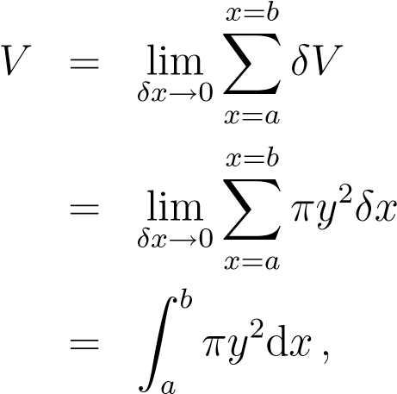

where we have changed the limit of a sum into a definite integral, using our definition of integration. This formula now gives us a way to calculate the volumes of solids of revolution about the *x*-axis.

METHOD OF SOLUTION:

*Let f*(*x*) *and g*(*x*) *be continuous functions on the interval* [*a,b*] *such that f*(*x*) ≥ *g*(*x*) *for all x in* [*a,b*]*. Then the area of the region between f*(*x*) *and g*(*x*) *on* [*a,b*] *is*

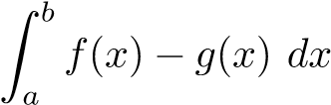

**Steps:**

To find the area of the region between two curves *f*(*x*) and *g*(*x*):

1. Set the two functions equal and solve for *x* to find any intersections points. *Note:* We’ll do this even if we’re given an interval in the problem (the functions could cross at some point in the interval, changing which is the upper and which is the lower function) *unless* we’re explicitly told/shown that they don’t cross in that interval.

If we are given an interval, then we only need the intersection points that lie in that interval.

1. We set up one integral for each pair of adjacent intersection/end points.
   1. If we’re trying to find the area between *f* and *g* over a given interval [*a,b*] and the functions intersect at *x*1*,x*2*,..., xn* **in** [**a***,***b**], then we would have

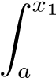 (upper1− lower1)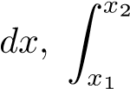 (upper2− lower2)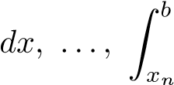 upper*n*+1− lower

* 1. If we’re trying to find the area between *f* and *g* overall (no interval given) and the functions intersect at *x*1*, x*2 *,..., xm*, then we would have

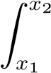 (upper1− lower1)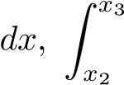 (upper2− lower2)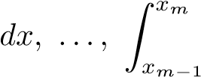 upper*m*−1− lower

Adding up these integrals gives us the total area bounded by the two curves (over the interval, if given).

1. For any of these integrals, if we subtract the functions in the wrong order inside the integral, then the answer will change sign (negative instead of positive). If that were to happen, we could simply take the absolute value of that number to find the correct answer.

To save ourselves some time and the trouble of having to either graph the functions or pick test values to see which is the upper and which is the lower over each of those intervals, we’ll simply subtract them in the same order in all of the integrals, evaluate, and then take the absolute value of each **before** adding them together to get the total area. For example, in (b) above, the total area would be



Solids of Revolution: The Washer Method

If the region we revolve to generate a solid does not border on or cross the axis of revolution,

then the solid has a hole in it. The cross-sections perpendicular to the

axis of revolution are *washers*  instead of disks. The dimensions of a typical washer are

Outer radius: *R*(*x*)

Inner radius: *r*(*x*)

Volume by Washers for Rotation About the x-Axis

FINAL SOLUTIONS:

QUESTION:

The region bounded by the curve y = $x^{2}$ and the line y = 2x is revolved about X-Axis to generate a solid.

SOLUTION:

To get the point of intersection y= $x^{2}$----1, y=2x-----2

Equation1= Equation 2

$⇒$ $x^{2}$ = 2x

- 2x = 0

$⇒$ x (x - 2) = 0

$⇒$ x = 0 or x = 2

And y = 0 and y = 4

Then when we Rotate the curve along X-axis

$⇒$ π ($R_{2}^{2}-R_{1}^{2}$) dx

$⇒$ π ($y_{2}^{2}-y_{1}^{2}$) dx

$⇒$ π [ ${\left(2x\right)}^{2}-{\left(x^{2}\right)}^{2}]$ dx

$⇒ π\int_{0}^{2}{\left(4x^{2}-x^{4}\right)}$ dx

$⇒ π$ $\left[\left(4\right){\left(\frac{x^{3}}{3}\right)}_{0}^{2}-{\left(\frac{x^{5}}{5}\right)}_{0}^{2}\right]$

$⇒$ π $\left[\left(\frac{4}{3}\right)\left(8-0\right)-\frac{1}{5}\left(32-0\right)\right]$

$$⇒π[\frac{32}{3}-\frac{32}{5}]$$

$⇒$ 32 π ( 1/3 – 1/5 )

$⇒$ 32 π (5 – 13/15)

$⇒$ 64 π / 15 cubic units

Therefore the volume of the solid is 64 π/15 cubic units.

THE STEPS OF CONSTRUTIONS OF GEOGEBRA SIMULATION:

1. Take the f(x) and g(x) of the given question and open the GeoGebra enter the f(x) and g(x) in the given line in GeoGebra and then it forms the graph between the two curves.

2. Then the two curves are formed in the graph find the points of intersection of the two curve touch each other and then make same in 3-D then we can see the curves and were they intersect and the curves are formed.

3. Then use the washer method solve the problem and find the relation between the curves and find the integral limit value and then make the solution of the volume between two curves

4. Then Enter in the function in the blue input box below. Adjust the "a" and "b" values by using either the sliders or entering them in the input boxes yourself.

5. To the right is displayed what the solid of revolution would look like if you rotated the displayed area about the x-axis. As an exercise, try to calculate this volume and see how your answer compares to the volume displayed. (Note: For volumes that are irrational, the displayed value only approximates the true exact value.)

6. Then enter the values of relation of the two curves and the integral limit values and the rotate the curve through x-axis and we will get the figure of the curve then it forms solid shape we get the exact one in GeoGebra.

CONCLUSION

The conclusion for the project is we learn about the revolution of the two curves and the volume between the two curves and by using the GeoGebra and the main theme is to find the volume and how to make the curves in GeoGebra and 3-D shapes in the GeoGebra and how to use washer method and other with x-axis and y-axis and also any object take some points and mark it in the GeoGebra

We can rotate to form different types of 3D objects in our daily life. I think this can help me in creating some toys ,bottles and hollow objects etc.

**References**

**1 Thomas calculus.**

**2 GeoGebra.**

**3 Advanced engineering mathematics.**

**4 concept and pictures from internet.**

Acknowledgement

We would like to express special thanks of gratitude to my teacher M.R D. R ZIYA UDDIN, who gave us opportunity to work on this project.

Secondly, we thank our group members for their contribution and cooperation for making this project .This project was made from the support and contribution of our group members .so we will thank each of us.

THANK YOU